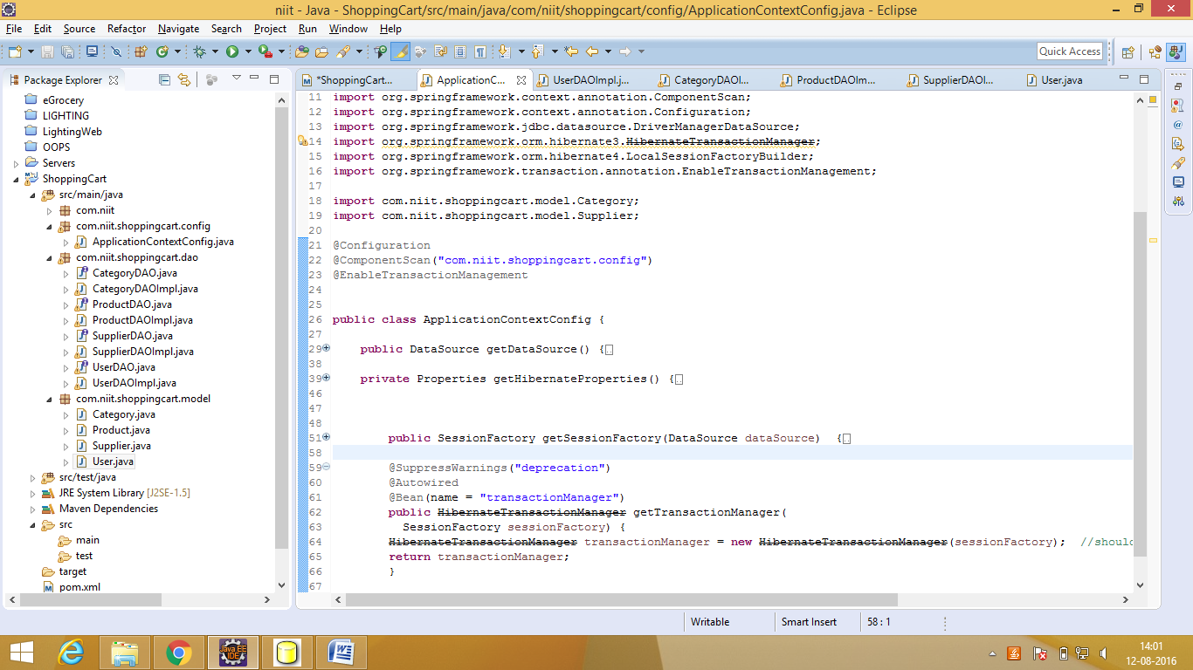

Both the hibernate class shld be same

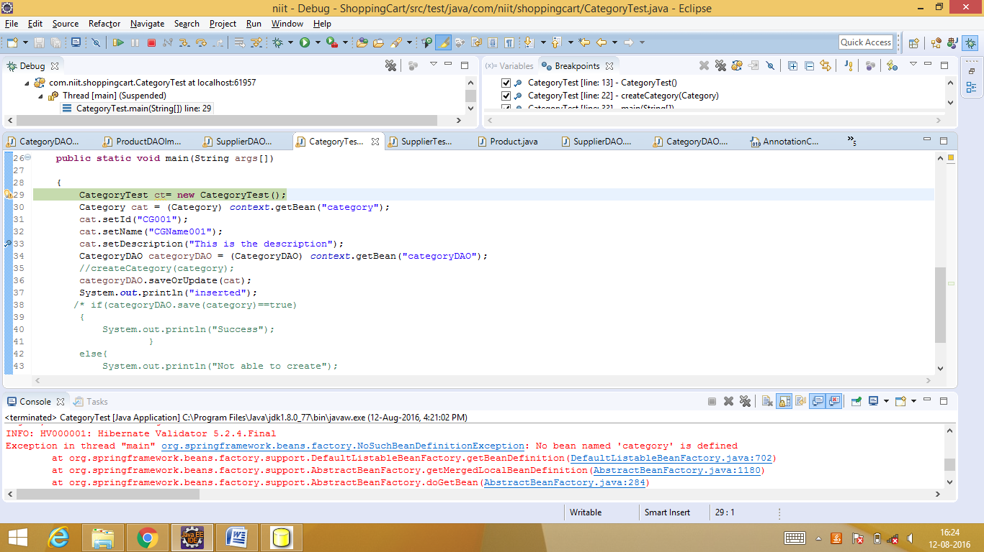

Add category bean to application context similar to categoryDAO bean and

Remove properties.put("hibernate.current_session_context_class","thread");

<http://www.codesenior.com/en/tutorial/orghibernateHibernateException-createQuery-is-not-valid-without-active-transaction>

for hibernate4 it is required

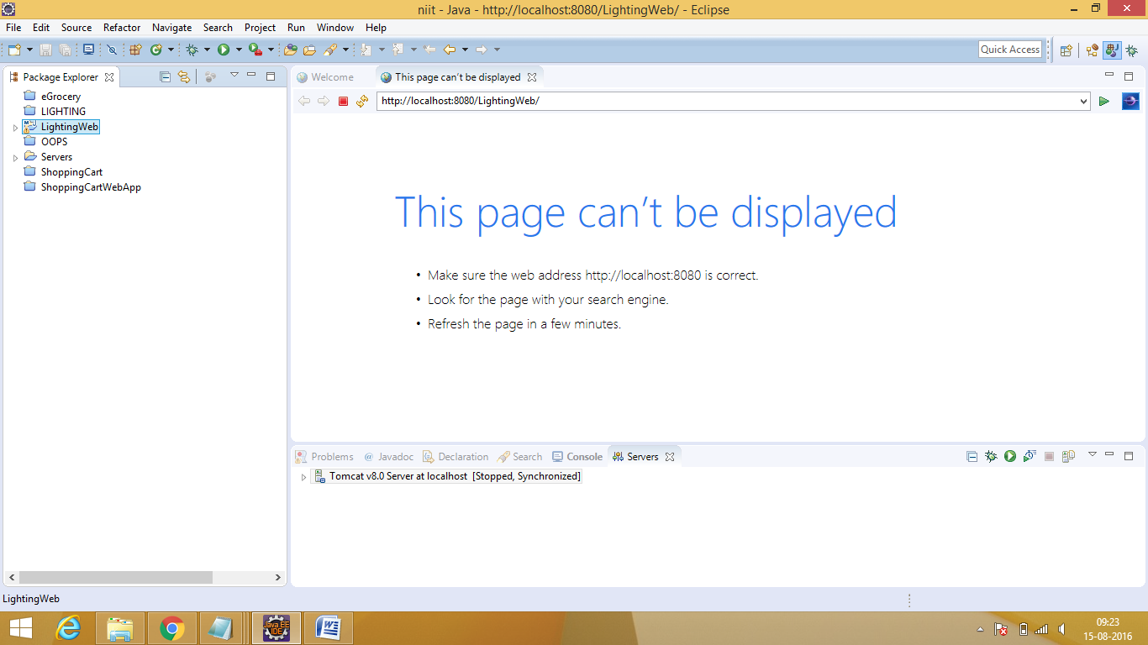

Tomcat error - Before we going to start our project we need to do some set of setups:

1)right ->click on your project -> select properties->go to java compiler

1. Select -> java compiler -> select jdk compliance ->1.8 version->click on apply button
2. Select -> java Build Path->libraries->select jresystemlibrary[j2se1.5] by default jre will be1.5

We need to click on Edit button-> select execution environments jre 1.8 and

Click ok button

9)select down installed jres-> should be jdk1.8

Select jre-> edit -> select a location where you have jdk1.8 location -> then select apply button

And click ok button -> then click on finish button -> then click on apply button

Go to->project facets->> select java 1.8 version and right side runtime -> apache tomcat location

Apache location:

Select apache tomcat where you installed / extracted:

And click on finish button

**OR**

1.WINDOWS->preferences->java->installed jres->add->std vm->find jre home(C:\jdk...)

Select jdk->apply

2. server->runtime envt.

3.build path->add libraries->apache location

* hibernate mapping error:

make the hibernate exception in impl class to exception

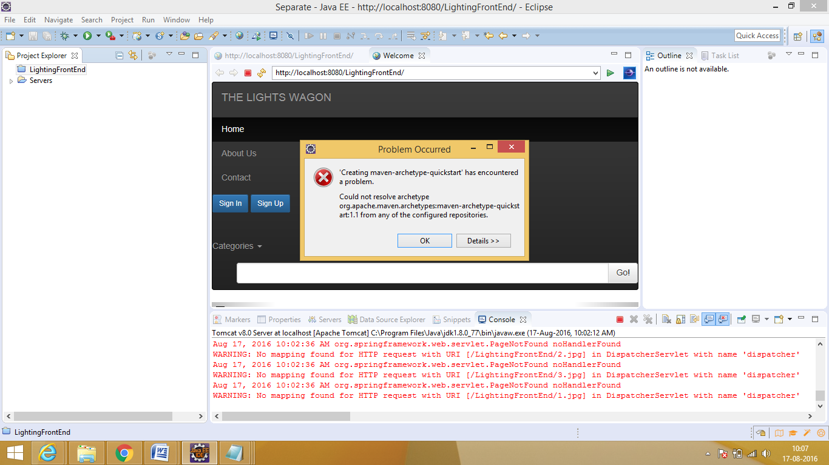

Create project frm cmd prompt

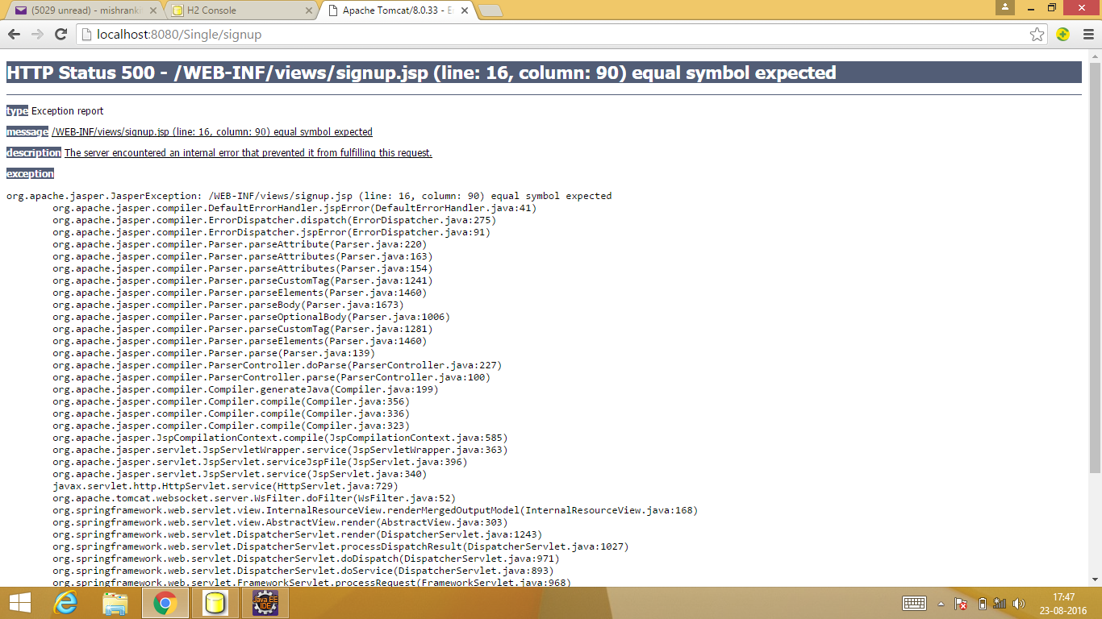

Input type= missing

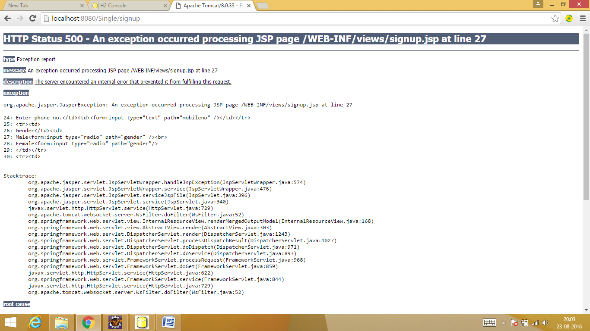

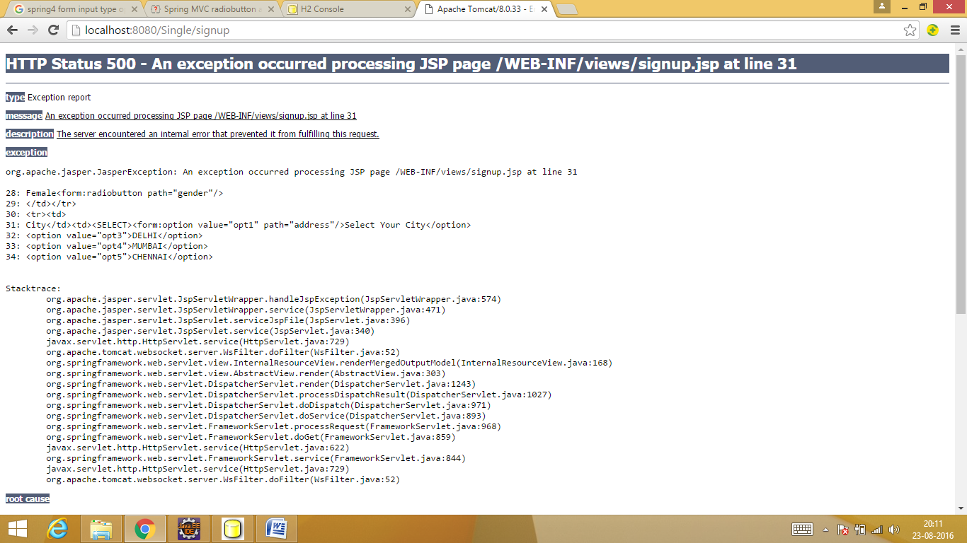

Option dropdown cant be done as normal html pg

25/08/2016

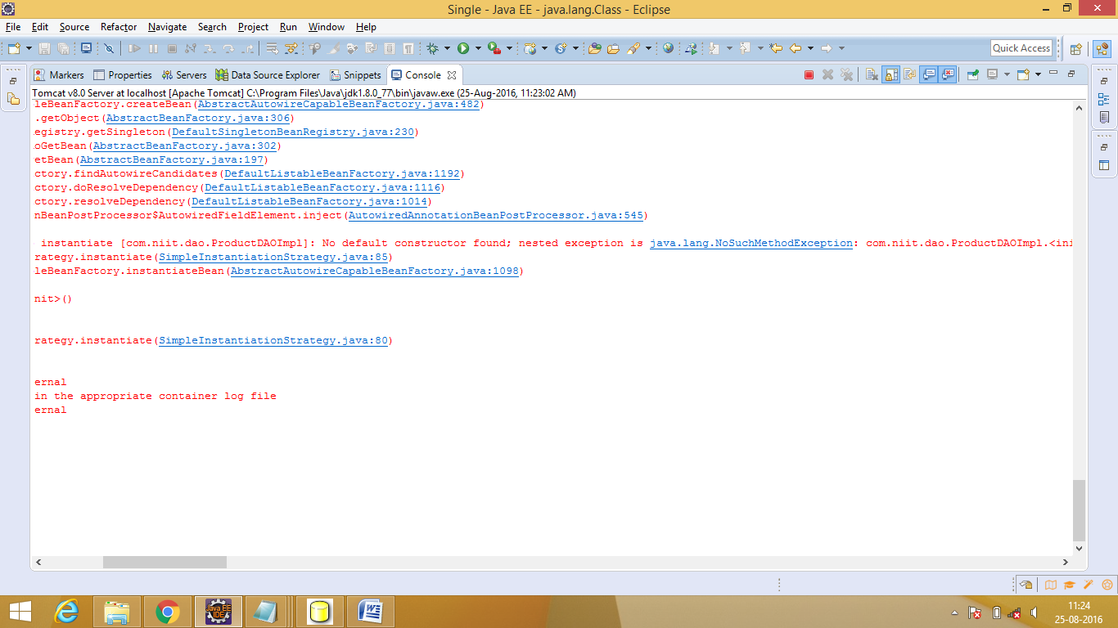

Clean tomcat(stop and start) and add spring-tx jar

27/08/2016

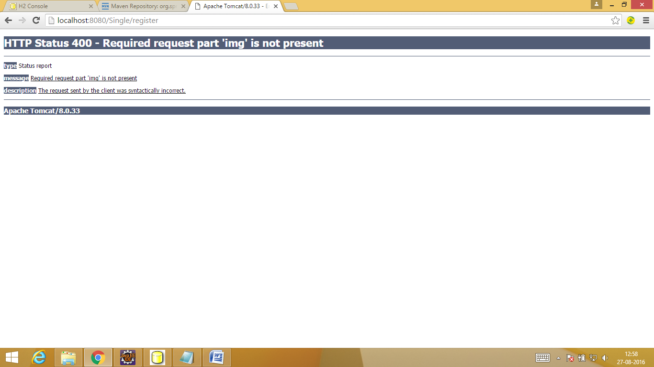

Img should be ‘image’=the name which is given in product.java

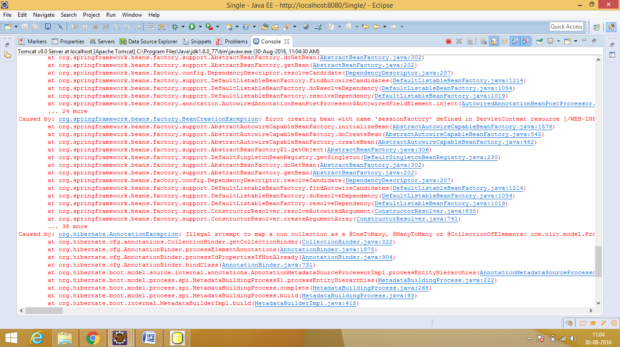

Need to create target class as hash set

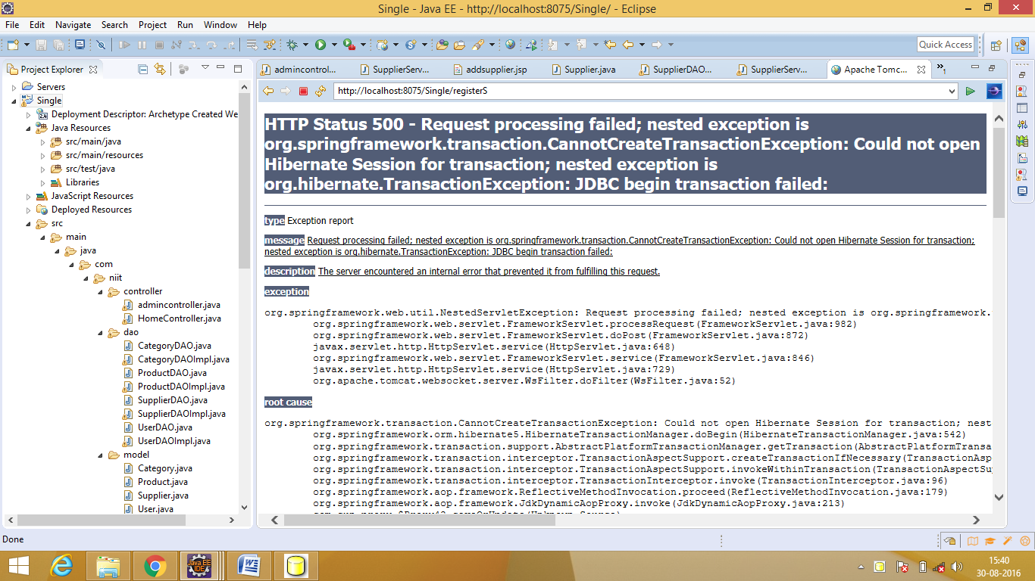

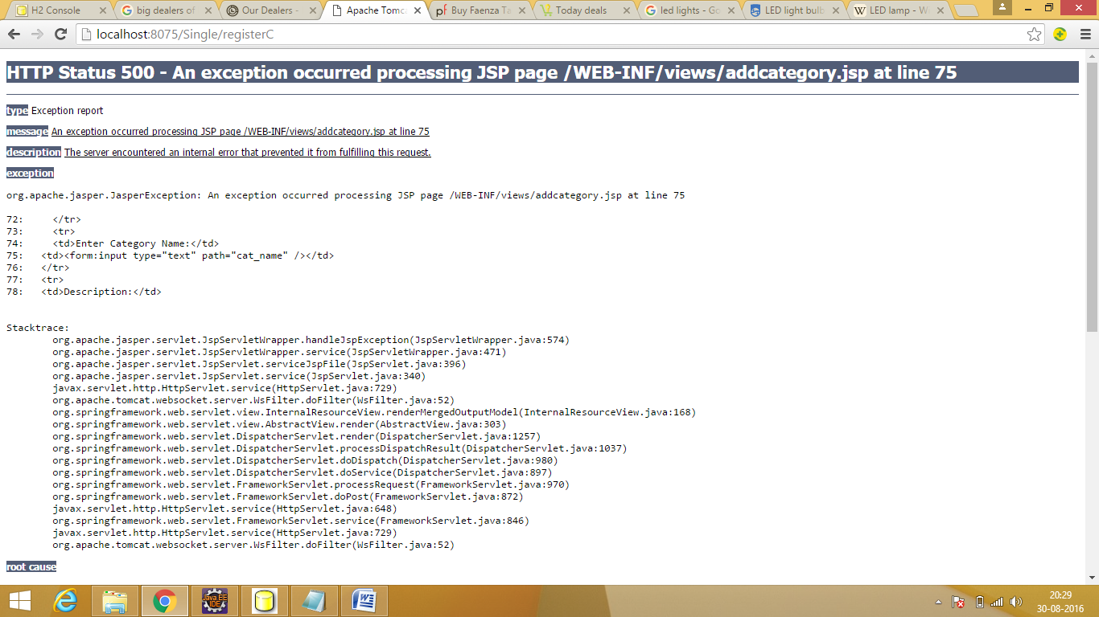

Bindingresult was missing in controller

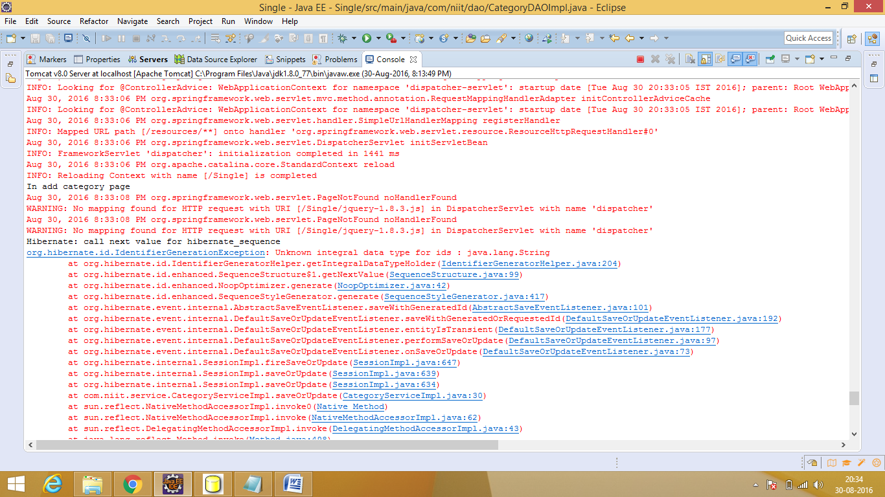

Datatype was string ...changed to int